**Assignment 1 - Wireshark Lab: Getting Started**

**Answer 1:**

The three different protocols in the protocol column are:

1. HTTP – Hypertext Transfer Protocol
2. TCP – Transmission Control Protocol
3. ARP – Address Resolution Protocol

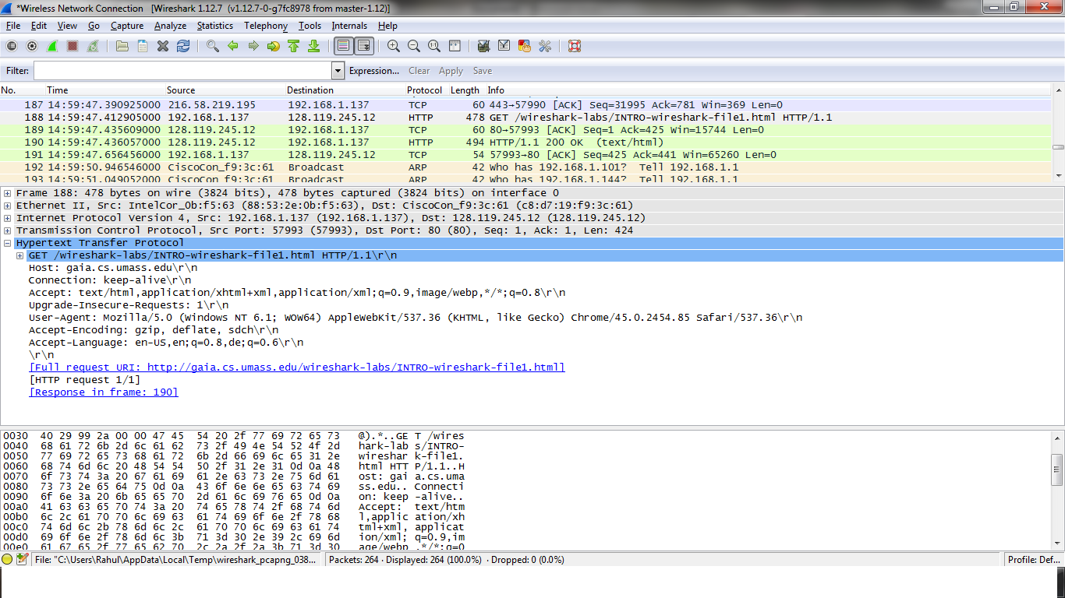

**Answer 2:**

The time at which the HTTP GET message was sent is = **14:59:47.412905000**

The time at which the HTTP OK reply was received is = **14:59:47.436057000**

The time elapsed between these two is = **0.023152** seconds



**Answer3:**

The Internet Address of gaia.cs.umass.edu is **128.119.245.12**

The Internet Address of my computer is **192.168.1.137**

**Answer4:**

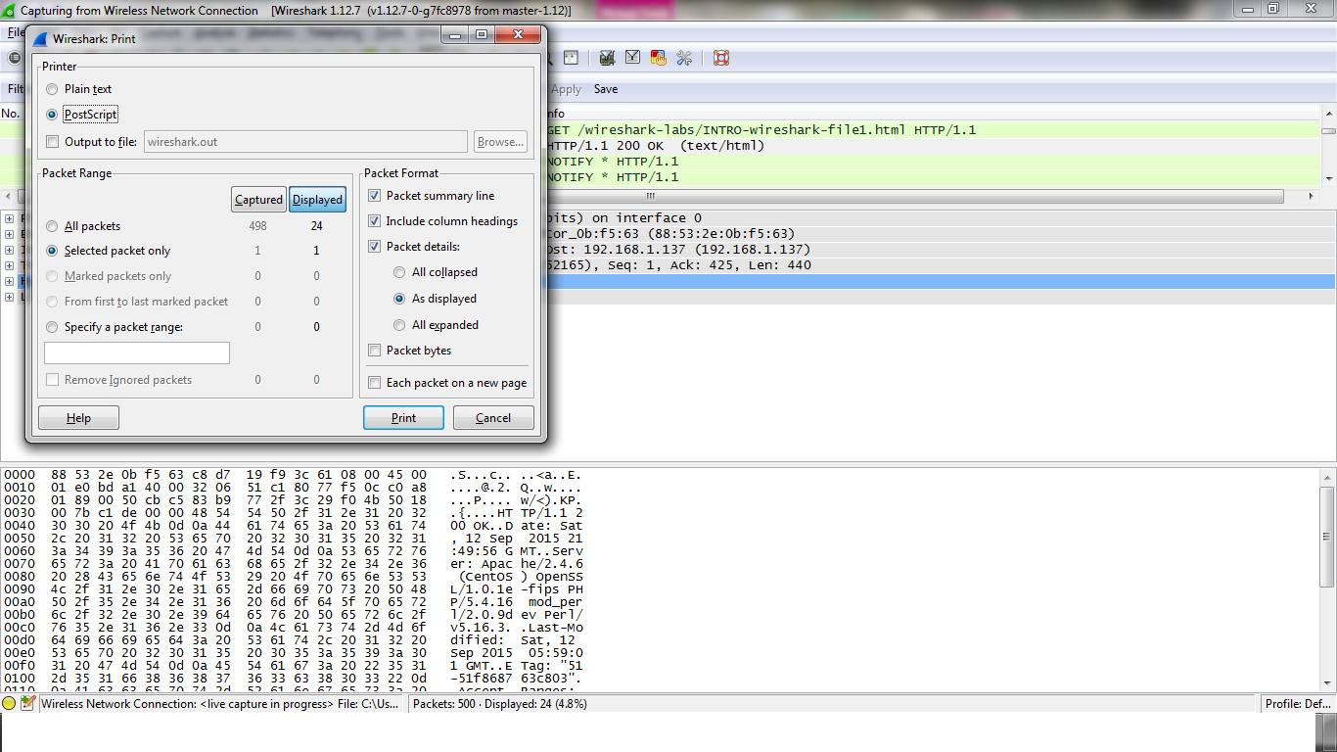

The two messages are shown below:

1. **Packet Print of GET message** –

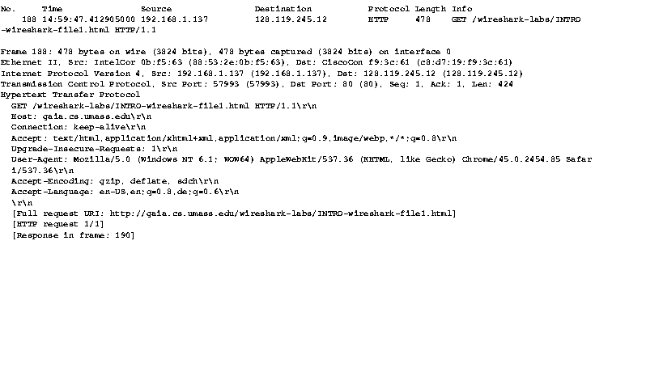

1. **Packet print of OK Reply:**

